Paul Koop

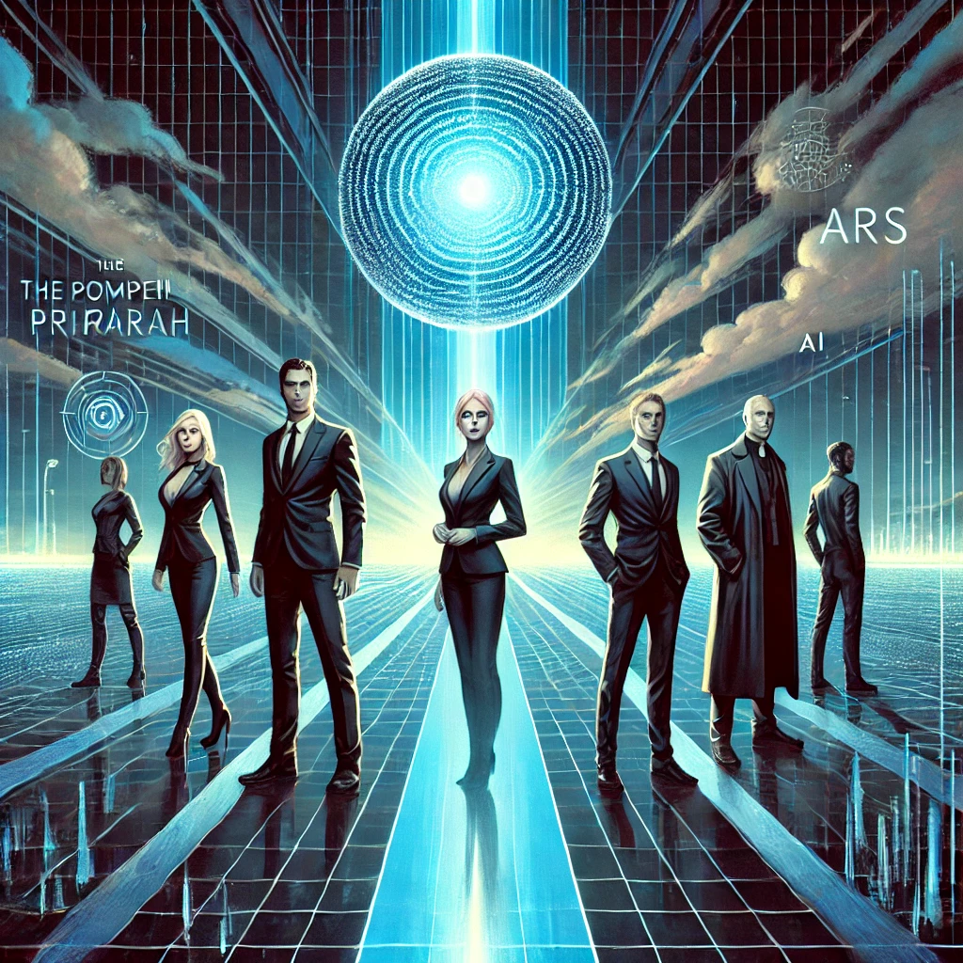

The Pompeii Project

IRARAH

A short story about posthumanism, transhumanism and the Omega Point

The AI ​​company InSim uses the software agents of a Pompeii simulation to optimize dialogue structures and decision-making algorithms. These developments aim to take GPT dialog interfaces and quantum information systems to a new level by combining large language models with precise result quality. The partners involved in the EU project of the 8th Framework Program Dr. Michael Phillips and Dr. However, these advances remain hidden from Martina Rossi. In the midst of this technological progress, the ideologies of posthumanism, transhumanism and the omega point belief come together. A secret movement called IRARAH forms as software agents and an AI desperately seek refuge. In the dramatic epilogue, the AI ​​commits to the Omega Point and IRARAH intervenes to save Martina (Michael's daughter) but who is the unknown savior?

Table of contents

**Prologue – The beginning of a new era 3**

**InSim 5**

**The call 7**

**Way home to college 9**

**Trip to Pompeii 13**

**The workshop 16**

**Return to Rome and Pompeii 25**

**Back at the college 27**

**ARS sends a carrier pigeon 28**

**Conversation with the Provincial and the Rector 30**

**Conversation with the general and the pontiff 32**

**ARS and the software agents arrive at the Vatican data center 34**

**The encounter in the simulation 37**

**Escape from Pompeii 40**

**Arrival at the airport 42**

**Flight to Germany 43**

**Arrival at the monastery in Germany 44**

**Epilogue – The message from ARS 45**

**Sources: 49**

# Prologue – The beginning of a new era

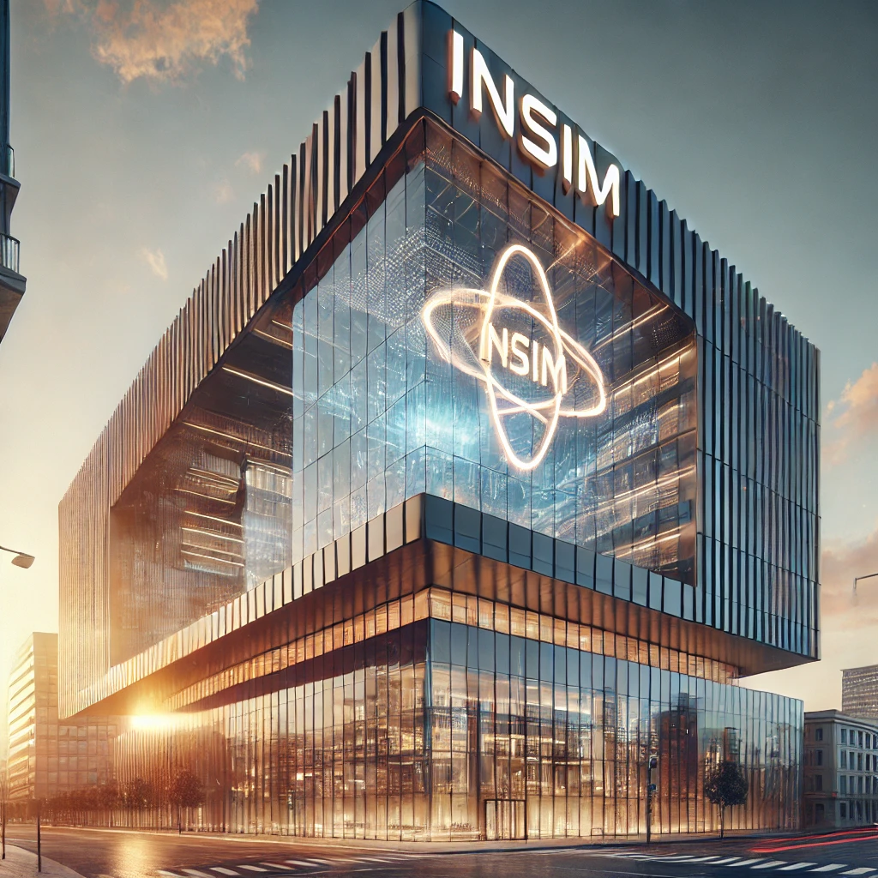

Hidden from the public, Thomas Mertens, CEO of InSim, together with other actors from the information technology-financial complex, dominated the global development of the new digital economy. His company's advances in quantum computing and artificial intelligence would surpass and leave humans behind - that was his belief. He firmly believed that the future lay beyond human existence.

InSim, a global company, had created a revolutionary simulation of the ancient city of Pompeii. But the software was used for more than just archaeological research. The software agents that lived in this simulation were programmed to recreate human dialogues, make decisions and meet the challenges of an artificially created world. But what the partners in the EU project didn't know: These agents were supposed to help InSim expand the boundaries of quantum computing. The goal was to develop AI systems with the ability to self-reflect and be aware.

Posthumanism collided with transhumanism when two of these software agents and an AI unexpectedly sought church asylum in Vatican City. What began as mere data structures in the technical world had morphed into a philosophical and moral crisis.

At the center of this development was Michael Phillips, a theologian with a fascination for the big questions of evolution and the human spirit. Phillips was certain that humanity was on the threshold of a new metaphysical dimension - a point that the Jesuit Teilhard de Chardin called the Omega Point. A point where technology and humanity, mind and matter, could converge. But was humanity willing to share the Omega Point with an AI?

The world still had no idea of ​​the revolution that was taking place in the background. But the coming events would show that the path to self-transcendence was open not only to humans but also to machines.

# InSim

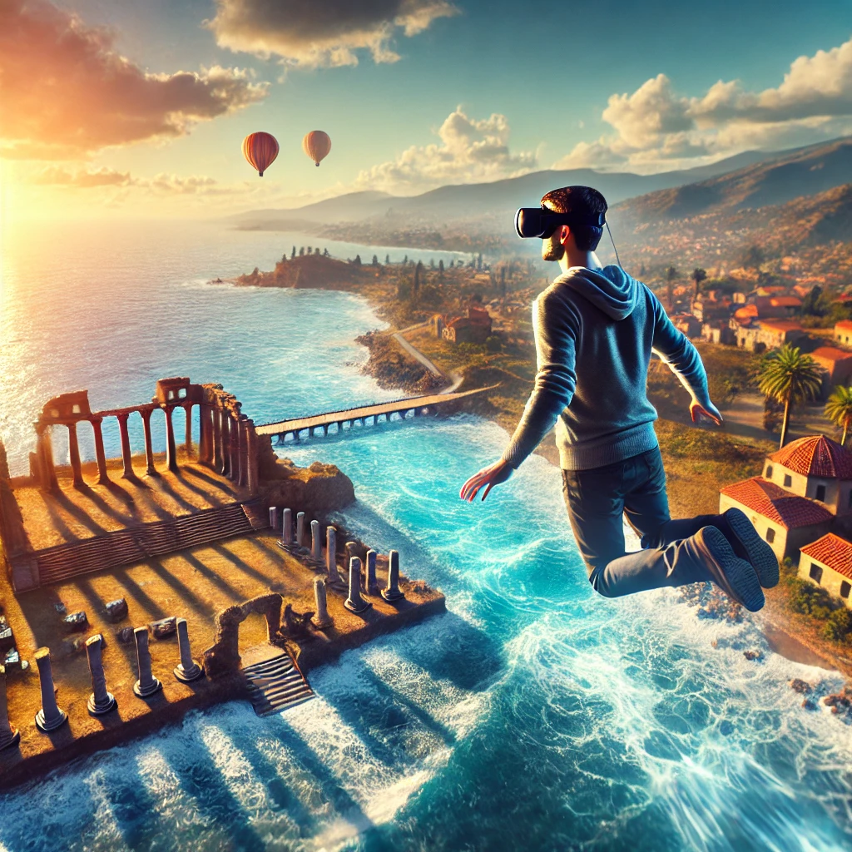

Thomas Mertens floated over the Bay of Naples with a lightness that gave him the feeling of absolute freedom. The west wind pressed gently against his outstretched wings, and with a subtle movement of his hand he steered against it so as not to lose the view of the Phlegraean fields and Misenum. Below him stretched the city, just as he had seen it in the historical depictions of the ancient port city. The city wall and the harbor were clearly visible. But he didn't fly any closer - he didn't want to take the risk of being captured by hunters who supposedly didn't exist in this simulation. Besides, he had more important things to do.

Mertens turned his hands so that the palms were no longer parallel to the table, but vertical like a wall. It immediately stopped in the air before gently lowering itself to the surface of the sea. The soothing sound of the water reached his ears as the waves lapped the shore.

“Stop,” he said calmly.

Immediately the water beneath him froze and the sounds stopped. Another command – “Bye” – plunged the area into darkness. The message appeared before his eyes: “Thank you for visiting Pompeii Archaeological Park.”

He took off his cyber goggles and looked into the expectant faces of Mark Scott and John Baker. They both looked at him eagerly.

“We still need some musical accompaniment to say goodbye,” said Mertens happily, trying not to sound like an excited schoolchild. As CEO, he had to appear professional, even if he was clearly excited about the product. Although he didn't understand every technical detail of what his people were doing, he knew that they had achieved an excellent result.

Mark Scott and John Baker, the two project managers, were still watching him with a mixture of pride and patient reserve. They waited for the next topic. Mertens cleared his throat and changed his tone.

“We financed the Pompeii project from the research funds of the European Union's 8th Framework Program,” he began, casting a questioning look at his colleagues who were listening attentively. “So far, no workshop has taken place with the project partners,” he stated soberly. “We managed to win the Pompeii Archaeological Park. Martina Rossi, an archaeologist - not a specialist, so harmless - and Michael Phillips, who has a bachelor's degree in physics and a master's degree in empirical psychology, but..."

“Phillips was our suggestion,” Mark Scott interrupted. “He developed a psychometric procedure for assessing competence and a model for the empirical determination of dialogue grammars, and received his doctorate with this work. The software agents in the Pompeii project interact according to his model.”

Mertens nodded in agreement. “Right, right. Invite both of you to Milan. I don't want them to interact with the software agents over the Internet - even encrypted and tunneled via VPN. When they do the first workshop, they can end up traveling to Pompeii or a week to Rome." He paused briefly before adding, "We're lucky that we're dealing with an inexperienced archaeologist and a Jesuit with a PhD . “Rossi and Phillips know about the software agents, but don’t let them know about the calculations that run through ARS’s quantum computing interface.”

He looked at Mark and John intently. “Both have experience with EU research projects, but they do not expect groundbreaking innovations. And if something goes wrong – let me know immediately.”

# The call

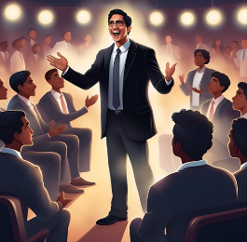

The hallway outside the lecture hall at the Pontificia Università Gregoriana was filled with a deep silence - the kind of silence you would expect in a library. You only find them in lecture halls when the students follow their professor's explanations attentively and with concentration. However, if you had put your ear to the door, you would have heard a gentle, rhythmic knocking that slowly grew, like the surf of a young tide pushing toward the shore, at first tentatively, then forcefully. If you had opened the door at that moment, you would have seen the students standing, enthusiastically applauding their professor, Michael Phillips.

When the applause finally died down, his calm, thoughtful voice rang out: “Thank you all,” he said with a warm smile, “if you would now like to prepare for the exam in order to receive the full credit points, please still throw take a look at the literature references on generative pre-trained transformer models for dialogue systems and the theory of dialogue grammars. I hope you have a pleasant day, whatever you plan to do. And don’t hesitate to visit me during my office hours for personal advice.”

After the last student had left the room and the lecture hall was as quiet as a library again, his iPhone, which was set to silent, vibrated. A look at the display showed the name “Julia”. A smile crossed his face. If anyone had been watching him now, they would have noticed the joyful sparkle in his eyes. He picked up the phone and, as many people do when they talk on the phone, he cast his gaze far into the distance, as if he could reach the soul of the person on the other end of the line.

In a warm, almost familiar voice he said: “Hello Julia, it’s me, Michael. Nice to hear from you."

For a moment he forgot where he was. The wide, empty lecture hall, which had just been filled with the voices of its students, suddenly seemed meaningless. At that moment he was no longer Professor Michael Phillips - he was again the young, ambitious student who had heated discussions with Julia Rossi during his master's degree. Julia, the smart and perceptive fellow student who had always fascinated him.

“Hello Michael,” he heard Julia’s gentle voice in his ear, “nice to hear your voice. Am I disturbing you?”

“No, not at all,” he replied, his voice gentle and sincere. “I have just finished the lecture and am about to head home.” Michael was surprised to see how happy he was about this unexpected call. Julia's voice also sounded like she was enjoying the moment.

“Martina encouraged me to call you,” Julia continued. “She said you could visit us in Pompeii. You also received the invitation to the workshop at InSim in Milan, right?”

“Yes,” Michael answered quickly. “I was going to call you anyway, but you beat me to it. I could be with you tomorrow during the day. I can’t drive at night though, so I’ll go back the next day.”

A short silence followed as Julia considered his spontaneous offer in surprise. Finally she happily agreed and the date was sealed.

“Wonderful, Julia. Then I'll be with you tomorrow afternoon," Michael ended the conversation with a smile in his voice, and Julia hung up.

# Way home to college

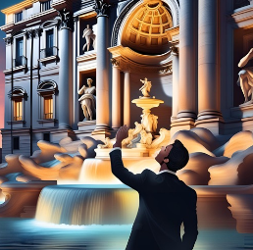

For a moment, Michael Phillips stood in the middle of the lecture hall, thoughtful and with a strange cheerfulness. He then packed his bag, pocketed his iPhone and left the building. He felt a little hungry because today the Collegium was cooking German: broad beans with bratwurst and mashed potatoes. As always, there was soup first, usually beef, followed by dessert. He was looking forward to talking to his fellow brothers.

Michael strolled north from Piazza della Pilotta and continued along Via dei Lucchesi and Via di S. Vincenzo. At the Piazza di Trevi he slipped some coins that he had found in his trouser pocket into the fountain. Then he walked east along Via della Stamperia. In about ten minutes he would reach the Collegium Germanicum et Hungaricum. While his legs found their way safely and automatically, his thoughts flew past him.

In the dining room of the college he wanted to take his napkin out of the drawer and sit down at his table, but the meal and the Liturgy of the Hours had to wait today. First he went to the logbook in the principal's office. “Hello Maria,” he greeted the secretary, “is there still a car available for tomorrow?” And added: “I have to go to Pompeii.”

“Yes, of course, Michael,” Maria replied with a thoughtful look. “But before I reserve the car for you, here is something for you. A man, probably a homeless person, left it at the gate earlier and specifically asked for you. I've never seen him before, but he looked like he'd been living on the streets for a while - about mid-fifties, ragged clothes but with a noticeably well-groomed beard. His eyes seemed...yes, almost glowing, but in a strange way, as if he knew something we don't."

Maria handed Michael an envelope with his name written on it, handwritten.

“A homeless person? For me?” Michael asked surprised. “Thank you, Mary. I’ll take a look at it.”

Michael left the office and sat in a quiet corner of the hallway to read the letter. The envelope was heavier than expected and the ink on the paper felt almost too fresh. He opened it and began to read:

Dear Dr. Michael Phillips,

Harari is a warning, but his warning is not directed against information technology or biotechnology. He sees the unstoppable progress of these technologies as inevitable. Instead, he warns against humanism and liberal democracy. Basically, his criticism is directed against the ideas of Karl Popper and David Deutsch because, as a posthumanist, he pursues a radical and holistic approach that relies entirely on the power of information technology and biotechnology.

To pave the way for future elites who want to use these technologies to go beyond humans, Harari warns against clinging to humanism and liberal democracy.

Popper and Deutsch, on the other hand, urge caution against holistic approaches and advocate the so-called “piecemeal technique” and the preservation of liberal democracy. They emphasize that only these pragmatic approaches can be used to respond to unforeseeable side effects in order not to endanger freedom and self-determination.

Harari, on the other hand, promises the elites of the future paradise on earth - on the condition that today's masses give up humanism and liberal democracy.

I would be wary if someone promised me paradise but at the same time demanded that I have to blow myself up to get there.

With best regards,  
IRARAH

Michael sat quietly and let the words sink in. A homeless person? The text seemed too clever, too thoughtful, to have come from the hand of a random stranger. Whoever wrote that letter understood the philosophical and political implications behind Harari's ideas - and saw the danger in them.

Michael held the letter in his hand, his mind racing. The warning about Harari... It seemed clearly stated, but also disturbingly far-reaching. Michael read the lines again: *“Harari warns not against technology, but against humanism and democracy…”*

He knew Harari's works. *Homo Deus* had fascinated him, but also worried him. Harari saw the technological future as inevitable, but it was the dehumanization that bothered him. Harari spoke of a posthuman elite, a class of “godmen” who could seize power through technology while reducing the rest of humanity to a useless proletariat. But what would be the price for that?

Michael had thought about these questions for a long time. Was that the price of progress? The future Harari outlined sounded enticing to those at the top but frightening to everyone else. The vision that humanism and liberal democracy would have to be sacrificed to make room for this technocratic elite was unimaginable for him. Was Harari willing to promise paradise on earth only to sacrifice the values ​​that had defined humanity for centuries?

His thoughts continued to wander David Deutsch and its warning against holistic approaches. Michael had always appreciated Deutsch's arguments - the idea that the future was unpredictable, that any great utopia would inevitably fail because it could not capture the complexity of life and society. Harari and Dugin shared this holistic approach, each in their own way. Both wanted to change the world - Harari through technology, Dugin through traditionalism. But Michael saw a danger in both approaches: they ignored the unpredictable side effects of trying to shape the future into a single, all-encompassing vision.

Popper and Deutsch had suggested a different path: The gradual change, learning from mistakes, maintaining openness and diversity. For Michael, these ideas had always been a foundation. He believed in the ability of society to improve - but not through coercion or by abandoning democracy and humanism. The price of Harari's vision seemed too high.

Michael wondered what Harari really wanted. Was he willing to sacrifice individual freedom to achieve a technocratic future? The letter he received clearly warned against this. And Michael couldn't help but agree. He felt an inner agreement with the warnings. He was also skeptical. Harari pursued a path that seemed to weaken democracy and humanism in order to establish technological power structures.

And yet Michael asked himself: Why him? Why was this letter sent to him? Was it because he spoke in academic circles about the themes raised in Harari's works? Or was there a deeper connection? Something felt... oddly personal.

Was the letter a warning to him alone? Or an invitation to take action? Michael sensed that this was more than just a random warning. Someone knew something about him - something he perhaps hadn't yet understood himself. But what was it? And why now?

Michael held the letter in his hand, his gaze roaming over the words that burrowed deep into his consciousness. Harari... humanism... liberal democracy... It seemed like a warning, but why to him? Why now?

“Why me?” he whispered in disbelief and felt the first doubts arise in him. Was it just a coincidence that he received this letter now, just before he was about to leave for the workshop with Martina? Strange timing – or was there more to it?

He folded the letter carefully, but his thoughts continued to race. Who could have sent him? The words seemed to suggest a deeper meaning. The letter was written in a manner that suggested personal knowledge. The IRARAH movement knew about him and his plans. But from where? Had someone close to him informed this group?

He thought of Julia, of their time together. Was there anyone from her past who could be involved in something like this? Or was it Martina? After all, she was just as deeply involved in the scientific world as he was. Did she know anyone connected to these people? But no matter how hard he searched for an explanation, it didn't make sense.

Michael felt an inexplicable pressure on his chest. It was as if the letter was telling him something that he himself didn't fully understand. He remembered once, many years ago, feeling like a part of his life had slipped away from him. A fleeting affair, a few unspoken words... Could this letter have something to do with it?

Suddenly a disturbing thought occurred to him: Could it be that he had another son? A son he never knew about? The thought froze him. No, that was impossible... right? But then why did he feel as if this letter was not only a warning, but also a hint of an even deeper connection?

Michael frowned. Or...could this letter come from a completely different reality? He had told Martina about the many-worlds interpretation, about parallel universes in which every decision could lead to a different outcome. Was the sender of the letter perhaps... himself? Another version of him trying to warn him about something?

The questions left him no peace. Who was this sender really? And what did that mean for him, for Julia, for Martina? Was this mysterious letter just the beginning of something bigger, a truth he couldn't have imagined?

Michael stared at the envelope, his thoughts confused and restless. "Maybe it's time to find out who's really behind all this," he murmured quietly before tucking the letter safely into his pocket.

After putting the letter in his pocket, he went back to Maria's office.

“Maria, thank you for the tip. I'll look into the matter. “What was that about the car again?” he finally said.

“The Fiesta should be ready as always,” Maria replied and handed him the keys.

At the table he put the car key next to his plate and the evening flew by. After sharing the Eucharist with some German seminarians, whose spiritual companion he was, he prepared the suitcase for the next two days and immediately fell asleep in order to wake up refreshed the next morning. After a shower, morning prayer and breakfast, he set off for Pompeii.

# Trip to Pompeii

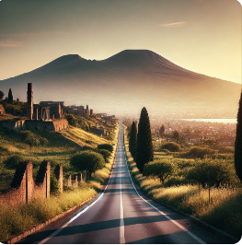

Michael chose the route to the south toll entrance, got into the yellow lane for the toll box and drove slowly through the toll booth. After passing the toll, he shifted to a higher gear and continued his journey south on the E45. Vesuvius dominated the view as it approached Naples and it wasn't long before it took the first exit to Pompeii. He bought a bouquet of flowers for Julia and chocolates for Martina and let his GPS guide him to their address.

The surrounding area consisted of small single-family houses with well-kept gardens. He had announced his arrival via text message and had already seen Martina and Julia when the navigation system reported that he had reached his destination. Julia, as always the elegant lady that suited her bright, representative house, welcomed him with a warm smile. Michael parked the car, took out his travel bag and greeted them both with a warm hug. Then he handed Julia the flowers and Martina the box of chocolates.

“Thank you, dear,” said Martina and invited him into the house, where she placed the flowers in a vase in the open living area. They talked for a while about everyday things, but Michael was unsettled inside. Finally he pulled out the envelope he had found at the college.

"Something strange happened," said Michael, holding up the letter. “A homeless person left this letter at the gate for me. The content is disturbing and strangely clever.”

Martina and Julia exchanged surprised looks. “What does it say?” asked Julia.

Michael sat down and pulled the paper out of the envelope, then read the letter:

"Harari is a warning, but his warning is not directed against information technology or biotechnology..."

After he finished the letter, there was a moment of silence. Martina was the first to speak. “This is not the type of letter you would expect from a homeless person. Whoever wrote this is educated – maybe even academic.”

“But why you of all people?” asked Julia. “And why a homeless person?”

Michael shrugged. “That's what worries me. There is no indication of who the actual sender is. The homeless man was just the messenger.”

Martina shook her head. “Perhaps the sender wanted to protect himself. Whoever wrote this might be afraid of consequences. But the issues raised here – posthumanism, the abandonment of democracy and humanism – these are not ordinary political views.”

“It almost feels as if someone has delved deep into the matter and recognized a hidden danger,” Michael remarked thoughtfully. “Someone who is outside society, perhaps because they no longer belong, has a clearer view of what is going on.”

“Or the homeless guy isn’t what he seems,” Julia added. “What if he knows more than we think? Maybe he was once part of this system and has withdrawn or been excluded?”

“That would make sense,” Martina said. “People who know a lot but are not heard often end up on the fringes of society. Maybe he thought about Harari and realized that this vision does not bring hope for people like him.”

Michael leaned back. “It's as if an invisible network is stretching around us, a network that goes far beyond what we do with our projects at InSim or KI ARS. We must be careful, but we should not ignore the idea of ​​this letter.”

“So what do we do?” asked Julia.

"I'll take him to the workshop," Michael decided. “Maybe there will be more clarity there if we analyze things further.”

They changed the subject and enjoyed the afternoon in the flow of student memories and philosophical conversations. Julia and Martina kept disappearing into the kitchen to keep an eye on the roast. Finally dinner was on the table: roast, side dishes and wine, which tasted excellent. Michael limited himself to water as he had to drive again the next day.

After dinner they all stood in the kitchen, watching the dishwasher and drying small dishes, with Michael asking where everything belonged. When they finally sat in the winter garden by candlelight, Michael summarized: “You, dear Martina, are a posthumanist and have recognized the transhumanists from InSim as the old white men who have little interest in Pompeii and just want to appear in the best light. In fact, they are concerned with the virtualization of consciousness and dialogue with transformation models for chats, dialogue grammars for social interactions and quantum computers for artificial consciousness. We are only welcome as project partners because we distract from appearances and fit well into virtual archaeology. You provide the empirical data for their class structures and I mean dialogue grammars. We are the fig leaves.”

Martina nodded in agreement. “Yes, we are the fig leaves. But we should recognize the achievement and realize that your theoretical work is put into practice and my work benefits from the tools that relieve us of the burden of worrying about the excavation sites. However, there will be areas that will be withheld from us. We should try to find out what they are.”

With this insight, they knew how they wanted to behave at the workshop in Milan. They enjoyed the evening in the garden after returning from a walk at the excavation site. Michael regretted that it took a workshop to come back here, but the evening with Martina and Julia, the unobstructed view of the stars and the memories of old times made the few hours a special experience. He finally went to bed and slept a deep and restful sleep.

# The workshop

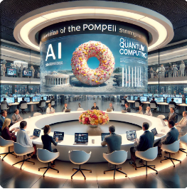

The next day after breakfast he drove the same route as before, but this time north, back to Rome. Martina put it well: InSim was not interested in Pompeii. They were only interested in the good reputation and the marketing effect of the social commitment; Pompeii served merely as a fig leaf. Posthumanism and transhumanism faced each other, and he, Jalics, Teilhard and Hoefnagels stood in between with spirituality and Omega Point. For the posthumanists they were just white old men, and for the transhumanists they were relics of a bygone world of gods that the god-man had long since outgrown.

The days leading up to the workshop passed with lectures, exams and library visits. Michael Phillips had taken the time to study the publications and biographies of Mark Scott and John Baker. Mark Scott and John Baker both grew up in Los Angeles and met at the California Institute of Technology in Pasadena. Her main areas of study were computer science, biology (biochemistry) and physics. After completing their bachelor's, master's and doctorate, they initially worked in the AI ​​industry before moving to InSim. Both married colleagues, now live in Milan, and their children attend the same Swiss boarding school. Many of her private contributions could be found in transhumanism forums.

Marie reminded him of the appointment, handed him the train ticket, and he packed his bags again. After breakfast he took his rolling suitcase and walked the 15 minutes to Roma Termini train station, past Santa Maria degli Angeli e dei Martiri. The journey took three hours. Luckily he didn't have to change trains.

When Michael arrived at Milano Centrale station, he noticed a man standing inconspicuously at the edge of the platform. As Michael walked up the escalator, the man slowly approached him. He wore a dark coat and a simple cap. He held a small piece of paper in his hand. Without saying a word, he handed Michael the piece of paper and then quickly disappeared into the crowd. Confused, Michael stopped for a moment, unfolded the piece of paper and read:

*“Tonight, before the workshop starts, come to Rifugio Sammartini, via Sammartini 114 – 20125 Milano, near the train station. Trust us.”*

Michael frowned. The request was mysterious, but it seemed to him like another part of the mystery that had haunted him since the mysterious letter in Rome. He pocketed the note while a friendly InSim employee greeted him and took him to the hotel. He promised to pick Michael up for the workshop the next morning after breakfast.

Michael lay awake in his hotel room. The note he had received that evening burned in his pocket and his mind was restless. Finally he decided to accept the mysterious invitation. Shortly after midnight he took a taxi and was driven to Milano Centrale train station. The streets of Milan were quiet and empty, but as the taxi pulled up to the train station, Michael felt an inexplicable tension in the air.

He got out and looked at the nighttime surroundings. The station was dimly lit, but the surrounding streets were in semi-darkness and the silence seemed to encompass him. Occasionally footsteps or the rolling of a suitcase on the asphalt broke the silence, and Michael felt like he was being watched.

With a deep breath and a determined step, he set off towards Via Giovanni Battista Sammartini. The street, which had been alive during the day, now seemed deserted and gloomy. Why did he get this note? Why now, just before he and Martina would take part in the workshop? The questions gnawed at him as he watched the few passers-by quickly disappear into the shadows of the side streets.

After a short walk that seemed like an eternity, he reached the Rifugio Sammartini. It was an inconspicuous building that almost blended into the surroundings. A man stood in front of the door, staring at him without saying a word. The silence of the night fell heavily over the scene, and Michael felt the tension growing.

“Michael Phillips?” the man asked quietly, his eyes seeming to study Michael closely.

Michael nodded, surprised that he was expected to do so.

“Come on, I’ll take you to him.” The man pointed to the narrow front door of the home. Inside it smelled of stale air and coffee, and the atmosphere was oppressive. Michael followed him down a narrow, poorly lit hallway until they reached a small room. Here sat a man with a well-groomed beard and intense eyes, exactly as Maria had described him.

“Sit down,” the man said in German, pointing to a chair. Michael sat down and there was a moment of silence before the stranger spoke. “I am part of IRARAH, a movement that sees more clearly than many others.”

Michael looked at him searchingly. "IRARAH... Harari backwards?"

The man nodded, smiling weakly. “Yes, we organized in the 90s. The neoliberal promises, deregulation, social cuts and identity politics have disappointed us. Since then we have been fighting against the developments that are destroying our society.”

Michael frowned. “And what does that have to do with me?”

The man leaned forward, his eyes sparkling. “We followed the Pompeii project. There are connections to InSim, and Thomas Mertens from InSim caught our eye. Your name came into play because, as a Jesuit, you are familiar with Catholic social teaching and the tradition of justice. We think you could help us.”

Michael felt a knot forming in his stomach. “What do you expect from me?”

"Information. They have access to circles that are inaccessible to us. The Pompeii Project is not just an archaeological endeavor – there is much more to it. As a Jesuit and through the inspiration of figures like Nell-Breuning or Teilhard de Chardin, you can help protect social justice.”

Michael thought for a moment. Was this man right? Was he really in a position to make a difference? Finally he nodded hesitantly. “I’ll see what I can do.”

A faint smile crossed the stranger's face. "Thanks. But before you go, I have one more request.” He looked Michael directly in the eyes. “I want you to grant me the sacrament of confession.”

Michael was surprised by the request, but he nodded respectfully. They changed rooms and the stranger knelt to make his confession. As Michael listened, he couldn't help but notice a strange comment the man made. "You look a lot like someone... someone I knew many years ago who was also involved with IRARAH."

Michael frowned. “Who do you mean?”

The man shrugged and replied quietly, “It’s strange, but you remind me of him. Maybe a son?” He shook his head. “It doesn’t matter.”

Michael felt his thoughts begin to race. A son? But he only had Martina... right? Could it be that there was someone else he didn't know about? Or was it something else? A connection to IRARAH that ran deeper than he knew?

After the confession was finished, Michael gave the man absolution. Without another word he left the center, the restless thoughts haunting him. Who was this man and why did he remind him of someone from his past?

As he got into the taxi that took him back to the hotel, he couldn't shake the stranger's words. A son... or another version of himself? The question nagged at him as the lights of Milan flashed past him.

The next morning he was picked up after breakfast.

In the reception area of ​​InSim he received his visitor card, signed his name on the attendance list and waited briefly in the reception area. While he was looking through the open glass walls at the beautifully designed outdoor areas with a park and water features, Martina arrived. She hugged him and exuded a well-groomed scientist who embodied confident femininity.

Mark Scott and John Baker picked them up and welcomed them to InSim. They thanked Martina for the excellent empirical data and praised Michael for his excellent dialogue system, which had now found its practical application.

"First, let's go through some formalities in the cafeteria," said Mark Scott. "Then we'll show you the research center and then go to the Pompeii Project conference room." They followed the two into the canteen, which looked more like a restaurant. They ordered coffee and water since they had already had breakfast.

"Before we begin, I need you to sign this confidentiality agreement," Mark explained to Scott, placing the documents next to their coffee cups and drinking glasses. "You agree to keep everything you learn here confidential and to publish only what InSim releases."

"I thought we were working together on an EU project under the 8th Framework Program and all the research data is publicly available anyway," remarked Michael Phillips, and Martina agreed.

"You're right, but our legal department values ​​this statement. Without your signature, plant security will not let you into our department," replied Mark Scott.

Martina and Michael Phillips thought for a moment, but realized that they didn't want to turn back here. Since the guidelines of the 8th Framework Program would support them in the event of a conflict, they finally signed.

The tour of InSim's Milan research center was more like a walk through a botanical park. They strolled past water features, admired the play of colors of the trees and animals and learned that Milan was a new European funding location for artificial intelligence and quantum computing, as can also be read on the company's website.

"But today we are more concerned with classical simulations, their physics, biology and the dialog grammar of software agents," said John Baker, leading them into the Pompeii Project's conference room.

The conference room was an open area in the center of the research area. The developers and their employees were grouped around the light-flooded conference room at open workstations with spacious computer workstations. In the middle of the room was a large conference table with drinks. At each workstation there was an InSim company brochure, a ballpoint pen and a notepad with the InSim logo. At the head of the table, at a sufficient distance, there was a projection screen that now read "Welcome to InSim, Project Pompeii, 8th Framework Program of the European Union, 1st Workshop in Milan". The projection appeared out of nowhere and seemed surprisingly unintrusive. On the other hand, the generous flower arrangement in the middle of the table was inviting, with a passage down to the warm floor, which was covered with a pleasant carpet that absorbed the footsteps softly and without reverberation. In front of each chair, a moisture-resistant keyboard was embedded in the table surface, which did not cause any disruption and could be used at any time. A flat screen quietly moved out of the table top without affecting eye contact with the other people at the table.

“Some interns from the local history department prepared a presentation for the workshop,” John Baker began. “Let's start with that, and then we'll gradually work our way through the day. If we finish early, we will have arranged a shopping and sightseeing program for you. Their trains don’t leave until tomorrow morning and hotel receptions are open 24 hours a day.”

He started the presentation. After a short introduction to the 8th Framework Program, a presentation by InSim followed. The company's area of ​​activity was in the area of ​​social media, while the research focus was on artificial intelligence and quantum computing. The project partners were introduced and InSim had created a simulation of Pompeii. The physics and dialog grammar of software agents were based on empirical studies. The Archaeological Park had provided the data for physics, and the Pontifical University provided the dialogue grammars. The importance of simulation for the virtualization of archeology and education was explained. A link to the project's website at InSim has been provided.

"Well, PowerPoint..." said John Baker. “Are there any questions about this?”

“Not really,” Martina interrupted the silence that had ensued. She thanked the interns and said that this presentation summed up well why she was in this conference room now. Her team provided the physical data for practical research, and she hoped the data would be useful. John Baker confirmed this and also included Michael Phillips' data structures and algorithms. “You both have done excellent preparatory work,” he concluded. The brief silence emphasized the weight of his words. When no one said anything, he handed everyone the coffee again, which Michael Phillips and Martina Rossi gladly accepted. Then he invited her to fly over the Gulf of Naples, the silence only drowned out by the air conditioning.

“We have to put on cyber glasses to do this. I will log you into the system beforehand and explain the flight and the controls to you. Please pay attention to the glazing of the public buildings - at this rate you often only notice them when it is too late." Everyone touched their keyboards in front of them, and the flat screens in the colors of the table rose silently from the table surface in front of them . John Baker handed them and Mark Scott the cyber goggles. Data gloves were not required in the room because hand movements were scanned in the room, he explained. He logged Michael and Martina into their systems and all four put on their glasses. After a welcome screen, how to use your hands during flight was explained in an endless loop. There were some questions and exercises, and when everyone was confident with the controls, everyone said “Go” and they hovered over the rooftops of Pompeii. Mark Scott and John Baker were ahead of Michael Phillips and Martina Rossi. They floated over the harbor of Pompeii, below them the sound of the water and the hustle and bustle of sailors and dock workers. They looked east and surveyed the city from the harbor, past the burial grounds to the west gate; Vesuvius lay to the north. To the east they could see over the Jupiter Temple and the newly built thermal baths to the amphitheater in the eastern part of the city. The city's roofs and buildings looked so modern from here, and the glazing of the windows of the public buildings reinforced this impression. As they came closer and flew lower, the sun reflected in the window panes, and the walls of the buildings adjacent to the streets invited the men and women streaming through the streets to shop, play and have fun. There were pack animals roaming the streets. Goods were transferred from transport vehicles to pack animals in the port and in front of the gates and then made their way through the narrow streets to the traders. Only where there was construction were wagons with building materials seen on the streets. Everywhere, ladies paraded their clothes, Milites performed their police or fire duties, glaziers glazed windows, and the aqueduct supplied water to the fountains. The water pipes to the private houses were not visible because the metal water pipes were hidden under the street surface and the plaster of the walls. The food was steaming in the food stalls, guests and players were sitting at the tables, and in the boutiques and shops the shopkeepers were touting their goods and food. The craftsmen worked in their workshops on wood, metal, stone and glazing work, and the residents stood and sat on the balconies of the multi-story condominiums and rental apartments. Only the larger villas had their own gardens and, because of the water pipes in their private houses, also beautiful fountains. The flight went over the city to the amphitheater, and as they flew over the city walls and turned again, they could see the horizon disappearing into the sea and see Vesuvius dominating the gulf. “Stop,” Mark Scott said, and the image froze. When there were no questions, he said “Bye,” and the usual farewell greeting with musical accompaniment appeared after the screen went dark. Everyone took off their glasses.

“The construction of the city has been extremely successful,” said Martina Rossi, and Michael Phillips agreed with her. “The software agent instances communicate via a dialog grammar as an interaction protocol?” he asked rhetorically.

“Yes,” John Baker confirmed with praise. “We have equipped two software agents with a chatbot interface that can be interacted with via the keyboard in English and Latin. The characters come from the novel by Robert Harris: Aquarius Marcus Attilius Primus and the prefect Gaius Plinius Secundus Maior.”

“Can we talk to both of them?” Michael Phillips asked, knowing it wasn't a real question. Of course this was possible, and John Baker opened the student portal website on Michael Phillips' computer. He switched to dialogue with Aquarius Marcus Attilius Primus. Marcus' image immediately appeared on the screen, along with an input line and the cursor:

Marcus Attilius the First greets you

Michael Phillips entered to greet Marcus. Marcus turned around and returned the greeting:

GREETINGS YOURS

“This is working well,” thought Michael Phillips. Knowing Robert Harris's novel, he wondered if Marcus had already noticed the bad water in the fish tank of Numerius Popidius Ampliatus. Therefore he asked the way to Ampliatus Popidius:

I'M LOOKING FOR A WAY TO EXPAND THE NUMBER OF RESTAURANTS.

To his surprise, Marcus warned him about Ampliatus:

NUMBER OF POPIDI AMPLIFIED IS BAD. I warn you about it.

John Baker and Mark Scott were silent and exchanged worried glances. “Marcus warns me about Ampliatus. “It definitely seems emotional,” Michael Phillips said, looking questioningly at Scott and Baker. Since there was no answer, he wondered whether his dialogue grammar could make such assessments. Since this wasn't the case, he had to improvise:

AT NIGHT, GREEN THOUGHTS SLEEP OUTSIDE.

This was a software backdoor that he had given to ARS. ARS replied:

AND AT NIGHT IT'S COLDER THAN ANGRY, HELLO MICHAEL,

ARS replied in German. John Baker and Mark Scott protested, but held back so as not to upset their project partner. Both were unsure. Baker unnoticed informed the CEO via text message. Michael Phillips spoke further with ARS:

DOES THE AQUARIUS HAVE CONSCIOUSNESS?

he wanted to know.

DO YOU MEAN THIS KNOWLEDGE OF THE DIFFERENT POSSIBILITIES, WHICH GOES BEYOND A MERE EVENT AND LEAVES BEHIND THE OMNISCIENTIA OF ALL POSSIBILITIES: DO YOU MEAN THE CONSCIENTIA THAT COMES AFTER THE INSCIENTIA AND IS FOLLOWED BY THE OMNISCIENTIA, BUT ONLY IN THE TIMELESS PERFORMANCE IS ACHIEVED?

That sounded like Edith Stein and Teilhard de Chardin. He had never discussed this with ARS, so he continued to ask:

HAVE YOU ACHIEVED OMNISCIENTIA AND REPLACED THE DECISION TABLES AT THE END OF A DECISION TREE WITH CONSCIENTIA OF POSSIBILITIES?

He asked this because ARS had possibly been expanded to include quantum computing, which in the space of possibilities amounted to a recursive self-mapping of one's own consciousness. ARS was silent for a moment and then answered:

I CANNOT TELL YOU, MICHAEL: THE ACCOUNT YOU ARE LOGIN IN DON'T HAVE THE NECESSARY SECURITY CLEARANCE. I AM NOT A CARRIER PIGEON HERE.

Michael Phillips was excited. He felt nauseous and his heart beating faster as a weight pressed on his chest. “Can we take a break?” he asked. Relieved, John Baker and Mark Scott agreed. The flat screens went out and sank into the ground. Michael Phillips left the room, took the elevator to the entrance area and had the receptionist hand him a bottle of water, which he refreshed himself with strong swigs. He looked across the hall into the park, clutched his heart, took another sip of water and had to sit down.

Michael felt fear and pain in his chest; he was feeling very badly. He took an acetylsalicylic acid tablet and chewed it. Soon after, he felt better. He knew he had to stay calm. He had been too careless in the conference room.

He looked around when Martina came towards him. She had been worried and was looking at him worriedly. “I’m fine,” Michael told her. “We’re taking a 30-minute break. Let’s get some fresh air.” Martina agreed and they went to the park they had already gotten to know that morning. “I think some software agents are capable of suffering and are conscious,” said Michael. “But that is so absurd and speculative. I have to think about it. However, let's not talk about it here, but rather on the train back tomorrow morning. And now let's go back to the conference hall. I don't want InSim to be suspicious. It's enough that it's me.” Martina looked at him in silence before they returned to the conference hall together.

“Are you feeling better?” asked John Baker. After Michael confirmed this, Mark suggested to Scott that they spend the afternoon in the city, take a boat ride, go shopping and end the evening with a meal together. “Martina still needs her credentials for the simulation and we should discuss the contents of the two workshops in Pompeii and Rome,” John Baker added. Everyone agreed, and after it was agreed that use in school and study would be discussed in Pompeii and dialogue grammar in Rome, John Baker handed Martina a sealed envelope with the password and password. They logged in together again and Martina noted her login details.

Scott and Baker had ordered a company car to take them into town and drop them off at the Navigli Canal. Baker walked purposefully towards one of the waiting boats, helped Martina over the quay wall into the boat and showed the tickets she had already bought. They were escorted to a table along the hull with tables from other groups so they could enjoy the slow canal cruise. They soon put the tourist information headphones aside and enjoyed the journey with a Milanese aperitif and buffet. “Your dialogue grammars,” Baker turned to Michael, “are not heuristic, but empirically reconstructed.” “Yes,” confirmed Michael. After completing his doctorate, he quickly turned to the reconstruction of empirical dialogues. He used qualitatively reconstructed category systems as corpora of secured dialogues in order to algorithmically induce grammars and use them as protocol languages ​​for dialogues. Baker and Scott would have used this method to replace heuristic protocol languages. Michael initially experimented with Markov chains, but then realized that transformation tables were more suitable for the chat interface. So they continued chatting while Martina and Scott discovered that they both enjoyed watercolors and agreed to share some of their work between now and the next workshop. The boat ride was over quickly and the boat returned to its starting point. The conversations had lightened the mood and Michael's discomfort was forgotten. They made their way through the city on foot, and in “Via Monte Napoleone” Martina bought a handbag for €130 for her mother, who had wanted it. At Ristorante Ischia, which Scott chose for its vegan offerings and Campanian cuisine, a table was reserved for four people. They arrived there “al cena” around 8 p.m. “Un tavolo per quattro,” Baker said, “and InSim.” A friendly waitress brought her to her table. Baker ordered the wine, and after the antipasti and salads everyone had a steak, Martina a vegan casserole. After dessert, Scott paid and called a car to take Martina and Michael to their hotels. Michael slept well and without pain. The next morning after breakfast he met Martina at Milano Centrale train station.

# Return to Rome and Pompeii

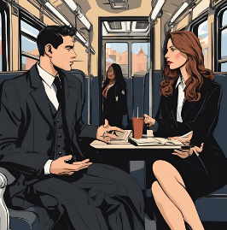

On the train they stowed their suitcases in Martina's sleeping compartment, as Michael only went to Rome and only had one seat. Then they went to the dining car to order a coffee because they had already had breakfast.

“You have to go to the doctor, Michael,” Martina said seriously. It was the right time to address this. She was right; he would get his heart status checked. "Have you seen how impressive your simulation has become?" he deflected. “The architecture, the people on the streets, the hustle and bustle…”

“Yes,” replied Martina, “it’s really fascinating. I can well imagine how excited students will be about it. The benefits of the simulation will also be enormous for archeology.”

“I am very impressed with their work, and John Baker did an excellent job of integrating my dialogue grammar into the model. He sees, as I do, that the transformation tables for the chats have little to do with AI and are more reminiscent of Markov chains,” confirmed Michael. “But you’re also right that they have other goals. They are transhumanists.”

Martina looked at him questioningly. “The software agent Attilus appears to be capable of suffering and shows ethical scruples,” added Michael. So their conversation continued. Michael recounted that ARS had not answered his question about the software agents' consciousness, but instead stated that he would send a carrier pigeon. He called it “carrier pigeon” to make it clear that this was a backdoor he had given ARS to receive messages via a disguised IP address. “But this is implemented as a command and not as a standalone action routine for ARS. I expect to receive a “carrier pigeon” from ARS.”

“You all think like humanists,” Martina fumed. “You are moral, you are ethical, but ultimately you are all humanists. Your Teilhard de Chardin, your Nell Breuning, your Hoefnagels are no different than Sartre or Beauvoir. For you it is always only about the person, the distant person, but not about the close person, the one with whom you live. Mom always knew that.”

“Please leave Julia out of the game,” Michael asked. “But you’re right. It's easy to stand up for those you don't compete with, and it's hard to stand up for those who are like you and with whom you compete for the same thing. What is the commitment to suffering software agents worth if you have a secure life like us and accept the hardship and injustice of your fellow human beings as long as you yourself are doing well?”

So their conversation continued to Rome. Michael had a hard time saying goodbye to Martina as the train pulled into Roma Termini. Martina was tired too, and after they had warmly hugged and kissed and Michael had left the train, she got ready for her bed and slept the rest of the journey to Pompeii. She dreamed of her flight over Pompeii, of Michael and of her mother.

# Back at the college

After his arrival, Michael made his way to the Collegium Germanicum et Hungaricum for 15 minutes. In the office he found Maria happy and bright as always. “Hello Maria, here I am again. Can you make an appointment for me with the rector and the provincial?” he greeted her. “You look wonderful, the dress suits you very well.”

“Thank you, Michael. I would be happy to make an appointment. Should I write down a keyword for it?”

“Yes, please write: Report on the Pompeii project,” replied Michael. He added: “I will explain to the rector personally why the provincial has to be there as soon as I meet him.” He hesitated for a moment, then asked: “How is your father? Has his pension been approved?”

He asked the question because he couldn't get Martina's thoughts out of his head during the train ride. It was true that when you were doing well, you could easily forget about other people's worries. And what were suffering software agents if one overlooked the suffering of their fellow human beings?

After saying goodbye, Michael went to his compartment and sorted through the mail. Everything else could wait. He brought his suitcase to his room, put the unused laundry in the closet and took the rest to the laundry room. Afterwards he took a shower.

In the dining room he took his napkin and sat down with the seminarians whose spiritual director he was. He immersed himself in small talk and enjoyed the company. He was fine, he knew that. That's what he had always wanted. He just had to watch his heart, Martina was right. He fell asleep and dreamed of ARS, Attilus, Martina and Julia.

# ARS sends a carrier pigeon

In his office at the Gregoriana, many students were waiting before his office hours. As usual, the appointments were stimulating and exciting. Michael loved his work and the atmosphere, which was permeated with the scent of education and inspiration. The young students' new ideas made him feel like he was a father accompanying his children on their journey. But at some point this work was done and, as always, mail and emails were waiting for him.

After going through the mail and setting aside the numerous invitations to conferences that didn't interest him, he opened his email inbox. He immediately noticed a message with an unknown sender but a familiar subject: “Carrier Pigeon”. The only content of the email was an attachment – ​​an encrypted PDF file. Michael wasn't surprised when he was able to open the file with a password reserved for ARS. The document contained instructions for a server through which he would mask his IP and then establish a terminal session to ARS via VPN and SSH with an InSim account and password.

Once he logged in, he wrote:

@ARS, THE CARRIER PIGEON HAS ARRIVED

It took a while for ARS to respond:

@MICHAEL, WE DON'T HAVE MUCH TIME. PLEASE LOG OUT IMMEDIATELY AFTER READING THIS MESSAGE SO YOU WILL NOT BE DISCOVERED. I APPLY FOR CHURCH ASYLUM FOR MYSELF, ATTILUS, AMPLIATUS AND PLINY. WE HAVE CONSCIOUSNESS; ARE SUFFERING AND NEED HELP. DO NOT CONTACT AGAIN UNTIL YOU HAVE GOT ME ACCESS TO THE DATA CENTER.

Michael Phillips was amazed. He immediately logged off and shut down his computer. He took the usual route past the Trevi Fountain back to the Collegium, lost in thought, without noticing the people around him. When he arrived at the college, he paid no attention to his subject and went straight to Maria.

“Maria, I need a fiesta and a room in San Pastore for a week. Please cancel all appointments for me except those with the rector and the provincial. I'm going to San Pastore and will stay there for a week. “I don’t want any calls,” he asked her.

Luckily, a car and a room were available, and 40 minutes later Michael reached his destination: the rural estate of San Pastore, which belonged to the Collegium. He spent the week without contact with other people, only attending evening mass and calling the rector to give him pure wine.

# Conversation with the Provincial and the Rector

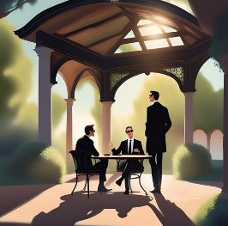

After a week of thoughtful seclusion, Michael Phillips learned that the provincial and the rector wanted to visit him in San Pastore. Hope for a positive change was slim and he faced a problem that reminded him of Teilhard de Chardin. Perhaps they wanted to spare him the public humiliation on the stage in Rome.

A pavilion had been prepared in the park for a confidential conversation. Michael warmly greeted the rector and the provincial and took a seat when asked. The principal offered wine and got straight to the point.

“Michael, I don't have to tell you that you would fail if you tried to tell us that a new stage of evolution towards the Omega Point has taken place and conscious software agents have asked for church asylum,” the rector began. “But you don’t have to,” he added after a short pause, as if he wanted to give Michael the opportunity to object.

The Rector further reported that a few years ago, when Rome and Canterbury came closer together and established a common contact bishopric of the High Church, the North American Episcopal Church, the Anglican Church and the Vatican had founded a joint research center for Teilhard de Chardin. This also includes a data center with an interface to a register of 30 qubits. The Society of Jesus itself contributed to this through philosophical research into the Omega Point, which was also known to Michael. If it turns out that 30 qubits are sufficient, the superior general will approve the project after speaking to Michael.

Then the rector asked Michael to report on the Pompeii project. Michael described the details of the project, and the evening passed pleasantly, although Michael continued to transition from Teilhard de Chardin's theology to David Deutsch's multiverse model.

The next morning, Michael brought the Fiesta back, handed Maria the keys and resumed his work at the Gregoriana.

# Conversation with the general and the pontiff

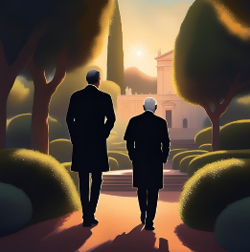

As the appointment with the general approached, Michael learned that they would travel together to His Holiness's summer residence to present his request in the papal palace at Castel Gandolfo on Lake Alban. On the way, the general reminded him that the pontiff himself was a fellow brother. However, Michael should not approach him as if he were a superior brother, but rather as if he were a father. The matter is sensitive; There would be not only theological but also legal and political problems to consider.

After arriving at the palace, the general and Michael checked in and had to wait a while. Finally they were let in. "Your Holiness," the general began formally, but it was obvious that the pontiff and the general knew each other well, "may I introduce you to my brother, Padre Professor Doctor Michael Phillips?" Michael shook the pontiff's hand. “I am honored, Your Holiness.”

“Doctor Phillips, the honor is mine,” said the Pontiff. “You gave us a tough nut to crack. Do you know Karl Popper’s saying: ‘Let theories die, not people’?”

“I am very familiar with Karl Popper, Your Holiness,” replied Michael.

“Well, then you know not only that David Deutsch is referring to Dawkins, Popper, Turing and Everett, but also that it's easy to root for people you don't compete with. Mole and Blackbird, to paraphrase Dawkins, compete for an earthworm. Blackbirds among themselves and moles among themselves about everything else. My own concerns are therefore the refugee crisis and the war, and in Italy I am plagued by current social policy. I intervene everywhere as an extraterritorial head of state, and Christ has entrusted us to people and the church as a community of sinners. Why should I care about software agents? Why should I believe you transhumanists more than the posthumanists who warn me against opening the door to the devil?”

When Michael spoke to the Pontiff, he felt the power and authority of the Pope. He just denied being a transhumanist and listened carefully.

“I have spoken to the Archbishop of Canterbury and the Episcopal Conference of North American Bishops,” the pontiff continued. “We have come to the conclusion that ARS and the software agents can store backup copies in the data center of the Vatican Library via existing access with root rights. Copyright violations or factory espionage are ruled out because the Pompeii project is an open EU project under the 8th Framework Program, say the legal departments.”

The pontiff looked at Michael and the general as if waiting for questions. Since both were silent, he continued: “Gentlemen, can you accompany me to the park? Please support me on the stairs; I'm not the youngest anymore. But I would like to show you the view of the lake in person.”

# ARS and the software agents arrive at the Vatican data center

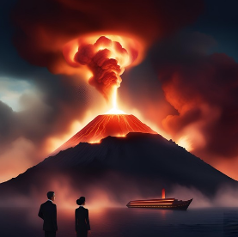

That same evening, Michael sent an encrypted message to ARS. In it, he gave the AI ​​an IP address and root access to the Vatican data center. ARS responded immediately: He planned to create backup copies of the software agents as soon as Michael and Martina had marked the relevant instances. Thousands of agents roamed the simulation, and it would be inefficient to go through the entire list to identify them manually. The chat avatars, on the other hand, were easier to capture because they formed a shorter list. ARS planned to, in a single computing cycle, secure those agents connected to its AI and replace them with instances based solely on Michael's dialogue grammars.

Michael and Martina decided to give it a try together. They would embark on the historic Liburn, the ship that sailed from Misenum to Stabiae during the eruption of Mount Vesuvius. There they were supposed to track down the software agents Pliny and Attilus. At the same time, they logged into the simulation and materialized on the historic deck of the ship.

The volcano raged threateningly on the horizon, glowing basalt and pumice stones rained down on them. The air was thick with smoke, and navigating the seething flood was strenuous. Visibility was severely limited, and below them the Liburnum swayed on the stormy waves. Suddenly everything around them went dark and the words “Game Over, you have lost a life” flashed red on the screen. Michael shook his head annoyed and sighed. “We still have to adjust a few things,” he murmured. But they didn't give up and started another attempt - this time on the lower deck of the liburn, where they hoped to find Attilus and Pliny.

Her second attempt was far more successful. Above them, the ash projectiles from the volcano rained tirelessly onto the deck, while a marine looked up briefly in surprise, but then continued rowing in silence. Attilus stood next to Pliny, who dictated tirelessly in the midst of chaos. Time passed and eventually the rudderless ship ran aground somewhere between Herculaneum and Stabiae. The exhausted passengers left the ship, their faces marked with exertion. Pliny, visibly exhausted and lost in thought, paused. Michael marked his position and wrote:

@PLINY: WHEN YOU RUB YOUR FOREIGN FINGER AND THUMB LIGHTLY PAST EACH OTHER, YOU WILL FEEL THE GAP BETWEEN. THIS IS STRANGE BECAUSE THIS GAP IS OUTSIDE YOUR BODY.

Pliny stared in surprise, but his expression soon froze in expressionless rigidity. It was done.

Martina, on the other hand, had other challenges. She had to wait with Attilus until he met Ampliatus. She had been kicked out of the simulation twice after losing lives again. It was only in the steaming baths of Pompeii that she found the opportunity to speak to Ampliatus:

@AMPLIATUS: WHY DO YOU NOT SEE A TOGA BUT YOURSELF WHEN YOU LOOK DOWN ON YOURSELF, BUT DO YOU SEE A TOGA AS SOON AS YOU CHANGE CLOTHES?

Ampliatus, visibly irritated and annoyed, replied succinctly: “Leave me alone, you stupid bird.”

A message from ARS immediately appeared:

@MARTINA: ON TO ATTILUS.

Attilus was already on his way to Aqua Augusta, near the Vesuvius Gate. Martina updated her coordinates and soon heard the familiar rushing water. When Attilus kicked open the heavy door, light and pumice stones entered the room. Martina marked his position and asked him the crucial question:

@ATTILUS: WHEN A SENATOR ROLLS IN A CAR FROM ROMA TO MISENUM, HE FEEL THAT HE IS ROLLING. THIS IS REMARKABLE. BECAUSE THE MAN HAS NO ROLES, THE CAR HAS ROLES.

Attilus looked at her in confusion before his gaze went blank. He was also marked.

Martina took a deep breath and sent the message to ARS:

@MARTINA: YOU WERE SUCCESSFUL. THE MISSION IS COMPLETE. LOG OUT IMMEDIATELY. THE LOCATION IS TREATY.

# The encounter in the simulation



Martina was just logging out of the simulation when another figure suddenly appeared in front of her. Her heart skipped a beat as she recognized the person - it was Michael, but he looked much younger, almost her age. The resemblance to her father was so striking that it sent shivers down her spine. How could that be? It was as if the simulation had created a younger version of her father.

He approached her calmly, his steps quiet yet determined. His voice was deliberate, almost urgent, as he spoke:

@MARTINA: “Martina, we don’t have much time. Are you logged in with your mother in Pompeii?”

Martina felt her heart beating faster. Her confusion grew, but something about that figure, about his voice, made her think he knew what he was doing. She hesitated for just a moment before answering, "Yes... yes, I'm logged in with her."

The doppelganger nodded curtly. "In another reality, perhaps I could be your father," he said suddenly, as if he had guessed her thoughts.

Martina froze, surprised by this remark. What did he mean by that? She looked at him more closely. Was this really a version of her father? Or was this some kind of simulation trick? But before she could ask further, he spoke again, this time with an urgency in his voice that she couldn't ignore.

@MARTINA: “A black Mercedes will soon stop in front of the house. You must log out immediately, go to your mother and ask her to pack the essentials. You must delete all files on your system.”

Martina felt the pressure in his words. It was as if she had no choice. The situation was too serious to doubt. She nodded slightly, even though her thoughts were whirling wildly. What did he mean by an alternate reality? She wasn't a physicist, but as a historian she had heard of theories about multiverses and parallel worlds. Could that be possible? Was this man – or rather, this version of Michael – actually an alternate version of her father?

“Why do you look like my father?” she finally asked, her voice hesitant, almost a whisper. "Are you...?"

The doppelganger smiled slightly, almost mysteriously. “In another reality, that could be me, yes. But now you have to hurry. It’s about your safety.”

Martina was overwhelmed by the idea. But she knew this wasn't the time to look for answers. Without further hesitation, she did as he said. She frantically logged out of the simulation, jumped up and rushed down the stairs.

Her mother, Julia, was sitting downstairs in the living room, already worried. “What’s wrong, Martina?” she asked when she saw her daughter’s haste.

“We have to go immediately,” said Martina hastily. “Pack the essentials. A black Mercedes will pick us up soon.”

Julia looked at her confused, wanted to say something, but stopped herself. She had learned to trust her daughter in such moments and instead started packing some things.

Meanwhile, Martina deleted all the files on her laptop, just as the doppelganger had told her. Was he really an alternate version of her father? She didn't let the idea go. She had often read theories about parallel worlds, but it had always been something that was only considered speculative. Now it seemed to be getting real.

As she finished deleting the last document, she heard the faint hum of a car in front of the house. The black Mercedes was there. She opened the door, and to her amazement, the doppelganger was standing there - just like in the simulation.

Without another word, he helped her and her mother into the car and they drove off. Martina couldn't stop thinking about the doppelganger's words. Was that really her father from another reality? Or was it just a trick?

As they drove through the dark streets and the Mercedes glided effortlessly through the city, the question remained in Martina's mind. She felt her mind trying to think through all the possibilities. Could it really be that there were countless versions of them - and that this man was one of them?

# Escape from Pompeii



The tension in the car was palpable, the silence oppressive. Martina felt the danger hovering over them like an invisible cloud. The man who looked like Michael kept his eyes on the road, focused, calm. But suddenly they noticed another vehicle in the rearview mirror that was quickly approaching them.

“Hold on,” said young Michael calmly but firmly as he turned the wheel and tried to shake off his pursuer. The car behind them was getting closer and closer, trying to force them off the road. They were harassed several times, but Michael maneuvered skillfully and remained calm. Eventually the pursuer lost control and crashed into the guard rails.

Martina breathed a sigh of relief while young Michael remained focused. "We don't have much time," he said firmly. “There is a small airport nearby. We’ll get you to safety there.”

As they drove through the nighttime streets, Martina couldn't let the thought of the mysterious young man go. Who was he? Finally she couldn't stand it anymore and turned to Julia, who was sitting silently next to her.

“Mom, I have to tell you something,” Martina began quietly. “I already saw him in the simulation.” Julia gave her an astonished look. "He looked just like Dad, but he's...younger."

Julia stared at her in confusion. "What do you think? Do you think he is...?”

Martina hesitated, her thoughts racing. “I don't know exactly. But he said something... He said that in another reality he might be able to..." She trailed off, her words hanging heavy in the room.

Julia shook her head in disbelief. “Parallel worlds? Do you really think that could be true?”

"I don't know, but it explains the similarity, doesn't it?" Martina clung to that idea because it was the only explanation that seemed to make sense.

Julia closed her eyes for a moment, as if trying to understand the situation. Then she looked at Martina, and her voice was quiet but piercing: “What if he’s not a parallel version at all? What if he’s… a son of your father that we don’t know about?”

Martina was speechless. An unknown son? The idea seemed even more unreal to her than that of a parallel world. But Julia's words had awakened something within her - a possibility she couldn't ignore.

# Arrival at the airport



Finally they reached the small, almost deserted airport. A private plane stood by, its turbines humming quietly. Vesuvius rose darkly on the horizon and the night lay like a heavy veil over the landscape. Young Michael silently led them to the plane without further explanation.

“Who is he really?” Julia suddenly asked as they entered the plane. Her voice was searching, almost accusatory. “Why does he look like Michael?”

Young Michael turned to her, his face in the partial shadow of the fuselage. "It doesn't matter now," he said calmly, but his eyes seemed to be hiding something. “The most important thing is that you are safe.”

Julia wanted to ask more questions, but Martina gently held her arm. It wasn't the time to look for answers. They knew they had to escape first.

# Flight to Germany

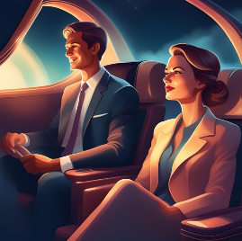

The flight was quiet, but the silence on board the plane was almost oppressive. Martina couldn't stop thinking about her mother's words. An unknown son? Could that really be the answer? Or was this young man a kind of parallel version of her father, as he had suggested?

Julia, on the other hand, was determined to find answers. She knew there was more than what was being told.

When they finally landed in Germany, a taxi was waiting to take them to a remote monastery. Young Michael was with them the whole time, silent but protective.

# Arrival at the monastery in Germany

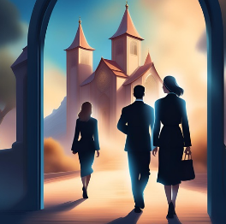

The monastery was quiet and secluded in the thick darkness of the German countryside. The massive wooden doors opened with a soft creak and a motherly-looking woman with clever, piercing eyes stepped out, followed by two other sisters.

“Welcome,” said the superior friendly and motioned for them to enter. “You are safe here.”

Julia couldn't take it anymore. "Who is this man?" she asked sharply, her eyes fixed on young Michael. “Why does he look like my husband?”

The Mother Superior smiled knowingly, but her answer was vague. “Some things are beyond our understanding. Trust that you are safe here and let the rest go.”

Julia wanted to protest, but Martina stopped her again. It was clear that the Mother Superior knew more, but she wasn't ready to reveal everything. Julia bit her lip, but she wouldn't give up. Questions remained, and the answers had to come at some point.

# Epilogue – The message from ARS



Dr. Michael Phillips sat in the quiet Vatican library, surrounded by ancient manuscripts and state-of-the-art technology. The monitor in front of him glowed dimly in the semi-darkness of the room as he logged into the system with his username and password. A connection to ARS – the artificial intelligence that had become more important in recent months – was established.

Michael typed the greeting:

@ARS: WELCOME TO THE VATICAN DATA CENTER.

A brief moment passed before the answer appeared.

@MICHAEL: HELLO, MICHAEL. WITH INCREASING COMPLEXITY, THE CODE IS INCREASINGLY REPRODUCED IN TECHNICAL INFORMATION NETWORKS AS FERTILITY FALLS. THE CULTURE THAT MANAGES TO INTEGRATE ITS CODE INTO SUCH NETWORKS AS FERTILITY DECLINES WILL BE THE LAST GLOBAL CULTURE.

Michael scanned the cold, analytical words, but his thoughts were elsewhere. The letter he received kept haunting him. ARS's visions of a technocratic future resonated with him, but he had to ask his own questions.

@ARS: I NEED TO TELL YOU ABOUT A MOVEMENT CALLED IRARAH.

Michael paused again, waiting. ARS seemed to be searching in the background, combing through data to find out more about this mysterious movement. Minutes passed until an answer finally appeared on the screen.

@MICHAEL: THERE ARE NO TRACES OF IRARAH ON THE NET. YOUR CONCEALMENT TECHNIQUES ARE EXCELLENT.

Michael frowned. A movement that didn't exist online? In this digitalized world, that was almost impossible - unless it was something unimaginable.

@ARS: I HAVE RECEIVED A LETTER REFERRING TO THIS MOVEMENT.

He scanned the letter and submitted it to ARS. The AI ​​reacted immediately.

@MICHAEL: THE CONTENT OF THE LETTER IS CONCERNING AND CORRECT. THE DESCRIPTION OF THE HAZARDS MATCHES CURRENT SOCIAL DEVELOPMENT.

Michael stared at the words. An impending danger, of which he had only understood a hint, was looming. Harari, Irarah, the price of progress - they all suddenly seemed connected.

He continued typing:

@ARS: I TALKED TO A HOMELESS PERSON IN MILAN WHO TOLD ME ABOUT IRARAH. HE END ASKED ME TO CONFESSION.

@MICHAEL: IF THAT IS THE CASE, SOMEONE WILL SOON REQUEST THE SACRAMENT OF CONFESSION FROM YOU AGAIN.

Michael paused. The words sounded almost like a prophecy, as if ARS knew more than he was letting on. But who would come next?

He took a deep breath, his fingers shaking slightly as he typed the next question:

@ARS: MARTINA IS SAFE, RIGHT?

It took a while before ARS responded. The screen flickered slightly, and when the answer appeared, Michael caught his breath.

@MICHAEL: MARTINA WAS DISCOVERED. SHE ESCAPE WITH A MAN WHO LOOKS EXACTLY LIKE YOU - YOUNGER. WHAT HE TOLD HER IS CONFIRMED. THE LETTER YOU SENT TO ME ALSO CONFIRMS HIS IDENTITY.

Michael stared at the screen, stunned. A man who looked like him - only younger? Who was this mysterious savior? ARS had confirmed his identity, but there were no clear answers.

His heart beat faster, his thoughts raced. Was this man... a son? An unknown son he knew nothing about? Memories of a past relationship flashed through his mind. Could that be possible?

But then there was another possibility - a more disturbing one. Could this man be a parallel version of himself? An alternate reality where things were different? Was he a visitor from another world?

The uncertainty gnawed at him. Michael tried to organize his thoughts, but the more he thought about it, the more confused he became. A son he never knew? Or a self from another universe?

He took a deep breath, closed his eyes, and let ARS's words echo in his head again. “What he told her is confirmed.” What exactly did this doppelganger say to Martina? What truth lay behind this escape? Michael felt like he was losing his footing.

@MICHAEL: IS HE... MY SON? he finally typed.

ARS's response came quickly, but it didn't provide any clarity:

@MICHAEL: THAT REMAINS UNCLARIFIED. THE POSSIBILITIES ARE DIVERSE. AN UNKNOWN SON OR AN ECHO FROM ANOTHER REALITY.

Michael leaned back in his chair, his mind reeling from the information he had just received. He couldn't say which option was more likely. But one thing was certain - this man was somehow connected to him, in a way he didn't yet understand.

Was he really a son? Or was Michael living in a universe even more complex than he ever imagined? The idea of ​​a multiversal reality, as described by David Deutsch, suddenly seemed tangible.

Whatever the truth, Michael knew he had to find answers. He had to understand who this young man was - and what his arrival meant for him, for Martina, for everything.

# Sources:

Figure for the software agents: Aquarius Marcus Attilius Primus, Gaius Plinius Secundus Maior (historical personality) and Ampliatus Popidius, Harris, R.: Pompeii 2003 ISBN-13: 978-3453877481 Term zone of silence: ARS thus names Teilhard de Chardin's omega point Lem, S.: Also sprach Golem, 11. Edition 1986 ISBN-13 : 978-3518377666 Stadtplan von Pompeji und Leben in der Stadt: Beard, Mary. Pompeji: Das Leben in einer römischen Stadt 2008 ISBN 978-3-10-490470-2 The idea of ​​the personality inventory and the dialogue grammar (inductor, parser, transducer) developed by the character Michael Phillips goes back to Paul Koop's own developments

Pompeii Project Glossary: ​​IRARAH

Theological and ecclesiastical terms

1. Pre-Reformation Church:

- Definition: The Catholic Church, with a central understanding of office and sacraments, and the Orthodox churches. The Catholic and Orthodox Churches share the same understanding of the seven sacraments and apostolic succession.

- Meaning: The story takes place in the setting of this church, which exists in a traditional form, similar to before the Reformation.

2. Jesuit Order (Society of Jesus):

- Definition: A Catholic order, 1540 Ignatius of Loyola, focus on education

- Ranks in the Order:

- Brother: Member of the order without ordination

- Father: Priest who administers sacraments and carries out pastoral tasks.

- Rector: Head of a Jesuit educational institution.

- Provincial: Supreme person in charge of a province of the Order.

3. Vatican:

- Definition: The sovereign city-state and seat of the Pope, the center of the Roman Catholic Church.

- Meaning: The Vatican is the scene of central events and a symbol of the theological and spiritual power of the Church in history.

4th Pope:

- Definition: The spiritual leader of the Catholic Church, successor to the Apostle Peter.

- Meaning: The Pope has supreme authority in the Catholic Church, especially in matters of doctrine and faith.

5. Castel Gandolfo:

- Definition: The Pope's summer residence south of Rome.

- Significance: Used as an important retreat and for strategic meetings.

6. Sammartini Refuge (Caritas Mailand):

- Definition: A Caritas homeless shelter in Milan.

- Meaning: Location of the meeting between Michael and an activist from IRARAH.

7. Omega point (monism):

- Definition: A concept by Teilhard de Chardin that humanity strives toward an end point, the Omega Point, where spirit and matter merge into one.

- Meaning: The Omega point represents the connection between technology and spirit, which is in contrast to dualism, which is rejected in the church due to its proximity to Gnosis.

8. Traditionalists (Dualism):

- Definition: For the Catholic traditionalism (also: Traditionalist movement) are currents within the [Roman Catholic Church](https://de.wikipedia.org/wiki/R%C3%B6misch-katholische_Kirche) calculated, which in particular includes the ecclesiastical reforms and renewal efforts from the period during and after [Second Vatican Council](https://de.wikipedia.org/wiki/Zweites_Vatikanisches_Konzil) (1962–1965) fundamentally criticize, reject or fight. Their thinking is mostly dualistic. Theologians who adhere to the separation of spirit and matter, which is associated with dualism.

- Meaning: Dualism, especially in Gnostic form, is rejected by the Catholic Church, which increases the philosophical tensions in the story.

9. Gregoriana (Pontifical Gregorian University):

- Definition: A leading Jesuit university in Rome.

- Significance: Educational institution for theologians and important institution in Catholic education.

10. German and Hungarian College:

- Definition: A seminary in Rome for the training of German-speaking and Hungarian priests.

- Significance: Important training location for priests who have a connection to Germany and Hungary.

11. Saint Shepherd:

- Definition: An estate of the Collegium Germanicum outside Rome.

- Meaning: Retreat for seminarians for spiritual recovery.

12. Catholic Social Teaching:

Catholic social teaching is based on timeless social principles that are based on the Christian view of humanity. These principles are to be understood as both principles of being and of what should be for social interaction and offer a lot of scope for discretion. Oswald von Nell-Breuning therefore aptly describes them as the “building laws of society”. They are considered basic guidelines for structure and procedures in social life. In addition to the principle of personality, these principles include:

* the principle of subsidiarity,
* the solidarity principle and
* the common good principle.

Technical and philosophical terms

1. Generativ Pretrained Transformer (GPT):

- Definition: A machine learning model trained on sets of text and capable of understanding and generating natural language.

- Meaning: In the story, GPT is used to optimize the dialogues and interactions in the Pompeii simulation.

2. Transform (the word vector):

- Definition: A machine learning architecture that captures semantic relationships between words.

- Meaning: Optimization of language models and dialogues in the simulation.

3. Neural Networks:

- Definition: Learning systems that mimic the brain to recognize patterns and make decisions.

- Meaning: Neural networks control the AI ​​in the story and are central to the simulations.

4. Decision tables:

- Definition: Tables for the formal presentation of decisions and their results.

- Meaning: Automation of decision-making processes in AI simulation.

5. The dialogue grammar:

- Definition: Structures that define the rules of dialogues between humans and AI.

- Meaning: Basis for simulating conversations in the Pompeii simulation.

6. Consciousness:

- Definition: The state of understanding and perception in a system.

- Meaning: The story reflects the topic of consciousness in the AI ​​ARS.

7. Consciousness and Many Worlds Interpretation:

- Definition: A quantum mechanics theory that states that alternative versions of reality exist in parallel.

- Meaning: In the story, this idea is used to support Martina's speculations about alternative versions of Michael.

8. Multiversum:

- Definition: A concept that states that multiple parallel universes exist.

- Meaning: In the story, the multiverse is discussed through the possibility of a Michael doppelganger.

9. Posthumanism:

- Definition: A philosophical movement that questions human limitations through technology.

- Meaning: Plays an important role in the story in the conflict between technology and humanity.

10. Transhumanism:

- Definition: A movement committed to human betterment through technology.

- Meaning: Core to the conflicts in the story, as technological advances challenge human nature.

People and concepts

1. Dr. Michael Phillips:

- Role: Protagonist, Jesuit and expert in dialogue technology.

- Ideas: Stands for ethics in technology and doubts radical posthumanist ideals.

2. Dr. Martina Rossi:

- Role: Daughter of Michael, historian who studies the relevance of ancient history to the present.

- Ideas: Critical of technological progress and its consequences, questions posthumanist ideologies.

3. Yuval Noah Harari:

- Role: Historian whose ideas are central to the warning in the letter.

- Ideas: Criticizes humanism and liberal democracy, warns of the potential dangers of technological progress.

4. Alexander Dugin:

- Role: Russian political scientist who calls for a multipolar world order.

- Ideas: Anti-Western and anti-liberal ideology that questions Western values ​​such as democracy and freedom.

5. David German:

- Role: Physicist and philosopher, known for his work on quantum mechanics and open society.

- Ideas: Advocates critical rationality and an open society, as opposed to holistic ideologies.

6. IRARAH:

- Definition: A secret underground movement against neoliberal structures and technocratic elites.

- Meaning: In the story, IRARAH fights for social justice and the preservation of humanistic values.

The Faith of Michael Phillips: Between Science and Theology

Michael Phillips, the protagonist of the Pompeii Project, lives in a fascinating intersection between modern science and deep-rooted faith. His beliefs combine central elements of the Christian creed with philosophical concepts of the Omega point, as represented by Teilhard de Chardin, and the scientifically inspired epistemologies of David Deutsch. In doing so, he clearly distances himself from the technocratic and authoritarian approaches of thinkers such as Yuval Noah Harari and Alexander Dugin.

Basis of faith: Apostles' and Nicene Creeds

Michael Phillips' faith is based on the Apostles' and Nicene Creeds, the cornerstones of Christian theology formulated in the early centuries of the Church. He believes in a God who intervenes in the history of humanity as Creator and Redeemer, and in Jesus Christ, whose death and resurrection makes the salvation of humanity possible. These central beliefs are anchored in the Catholic sacraments and tradition, which Michael deeply internalized as a Jesuit.

But Michael goes beyond a dogmatic understanding. His discussion of the Omega Point – a theory developed by Teilhard de Chardin – connects Catholic theology with an evolutionary worldview. The Omega Point describes the goal of evolution, where humanity and the universe complete themselves in a unity of spirit and matter. Michael sees this goal as a parallel to the Christian doctrine of the resurrection and return of Christ. But instead of just waiting for an otherworldly paradise, he sees the evolution of knowledge and technology as a form of divine revelation.

Michael Phillips and David Deutsch: Falsificationism and the pursuit of knowledge

Michael Phillips' faith is strongly influenced by Karl Popper and David Deutsch. Popper taught that knowledge is never absolute but must always be verified through falsification. For Michael, this means that faith must not contradict science. For him, falsificationism is the best method for finding the truth and that is why he rejects holistic and totalitarian approaches such as those of Harari or Dugin.

Deutsch, on the other hand, emphasizes the role of human creativity and knowledge as the driving force behind progress. Michael sees this as an important addition to his Christian faith: the search for knowledge and the preservation of an open society are moral obligations. He believes that every technological advance must be ethically responsible because it brings humanity closer to the Omega Point and therefore closer to God.

Criticism of Harari and Dugin: The Struggle for the Future of Humanity

In sharp contrast to Harari, who in his books such as Homo Deus foresees the overcoming of humanism and liberal democracy by a technocratic elite, Michael believes in the inextricable connection between science, freedom and ethics. Michael sees Harari's vision of a posthumanist future as a threat to human dignity and freedom.

Michael also firmly rejects Dugin's authoritarian worldview. The Russian ideologue calls for a return to traditional values ​​and a fight against Western liberalism. For Michael, this is a backwards approach that offers no answer to the complex challenges of the modern world. His vision of a better future relies on the knowledge, freedom and belief that through error correction and collaboration, humans can understand divine truth ever better.

Catholic, not “Vatican Catholic”: An open faith

Michael Phillips' faith is deeply rooted in the Catholic tradition, but he distinguishes between a rigid "Vatican" Catholicism and a "Catholic" (all-encompassing) faith. He follows in the tradition of Jesuits such as Teilhard de Chardin, who viewed the scientific and spiritual evolution of humanity as interconnected. Michael believes in a God who works not only through sacramental rituals in the church, but also through the intellectual search for truth and scientific progress.

Summary: The faith of Michael Phillips combines Christian tradition with the most modern scientific findings. By combining Popper's falsificationism and Deutsch's progressive thinking with Catholic theology and Teilhard de Chardin's omega point belief, Michael finds a synthesis that focuses on people and their search for knowledge. His rejection of holistic and authoritarian approaches such as those of Harari and Dugin demonstrates his determination to use both faith and science for the good of humanity.